RESQAI: AI-BASED ACCIDENT DETECTION, SEVERITY ASSESSMENT AND INTELLIGENT EMERGENCY RESPONSE SYSTEM
Conclusion, Future Scope and References
Department of Computer Science and Engineering, TKR College of Engineering & Technology
Batch A2 (CSE-A) · Academic year [ACADEMIC YEAR]
Table 1: Project team
S.No. | Student name | Roll number
1 | Adepu Meenakshi | 23K91A0503
2 | Ayila Shanmukha Sai | 23K91A0521
3 | Chekka Chandrashekhar | 23K91A0552
4 | Avula Sreeya | 23K91A0519

Project guide: Shirisha Reddy
Chapter and section numbers quoted in the text (for example Chapter 8 or Section 6.2) refer to the full project report, 17.Final Document. Figures and tables in this document are numbered from 1.

1. CONCLUSION

1.1 Summary of the work
ResQAI set out to shorten the time between a road accident and the arrival of help by detecting the accident automatically from the sensors that a smartphone already carries, judging how serious it is, asking the occupant to confirm, and then composing a located alert that names the nearest hospital. The base paper and the surveyed work [1] predict severity from records after the event, and none of it connects sensing to dispatch; this project built that connection as a working prototype and measured it.
The prototype is a Flask service with two random forests behind one scaler and a React console. A reading of eleven features is classified as accident or not, graded None, Minor, Moderate or Severe, and, for Moderate and Severe grades, held for a 15-second confirmation before the location, the three nearest hospitals and the dispatch message are produced. On 2,400 held-out events the detector scored accuracy 1.0000 and the severity model accuracy 0.99958 with macro-F1 0.99866; over five repeats severity accuracy averaged 0.99875. The whole alert path took 56 ms of computing on loopback, before the deliberate 15-second window.

1.2 Key findings
1. The pipeline works end to end. 33 of 33 smoke checks and 47 of 55 further checks pass; the eight that fail are input-validation gaps that the React screens cannot trigger.
2. On this data detection is easy and severity is where learning helps. A single threshold on acceleration magnitude detects crashes as perfectly as the forest; for severity the forest is clearly better than the threshold rule (accuracy 0.99958 against 0.9750, macro-F1 0.99866 against 0.9122).
3. Hard braking is not mistaken for a crash, but potholes and speed breakers are untested territory: constructed probes of both are flagged about half the time (49% and 50%), though never graded high enough to start a countdown.
4. The models tolerate light sensor noise and fail beyond it. Up to a tenth of the natural spread the detector is unchanged; at a quarter false alarms reach 1.2%, at a half 24.2%.
5. The human-in-the-loop design is what keeps false alarms cheap. The 15-second window and the restriction to Moderate and Severe results put the decision about contacting anyone in the occupant's hands.

1.3 Objectives achieved
Of the six objectives of the brief, one (severity grading) is achieved on synthetic data, one (hospital recommendation from location) at demonstration level, and one (evaluation) in full. Three are only partly met: data collection, because no real recordings exist; the separation of accidents from potholes and speed breakers, because only hard braking is handled; and the automated alert, because the message is composed and displayed but not transmitted. Chapter 8 gives the evidence for each.

1.4 Practical applications
• A teaching and demonstration platform for the structure of an automatic crash-response service: sensing, classification, confirmation, location, dispatch.
• A test bench for new detectors: any model that accepts the 11 features can be swapped into predict_from_features and evaluated with the same scripts.
• A starting point for a phone application and an insurer or fleet service that would receive the alert, once real data and a messaging channel are added.

1.5 Known limitations
The data are synthetic and the scores are upper bounds; road-surface events are unmodelled; nothing is transmitted; the input validation of the API has eight known gaps; and no user study was done. These limits are the agenda of the future work below.
The measurements behind the key findings are shown below: how the random forest compares with simpler models on severity grading, and how the shipped detector behaves as sensor noise grows.
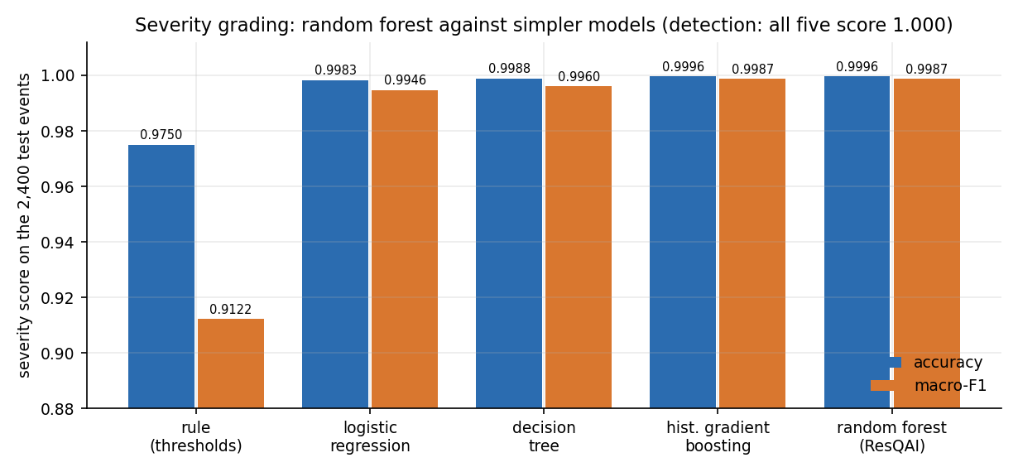
Figure 1: Severity accuracy and macro-F1 of the random forest and four simpler models on the 2,400 held-out events.
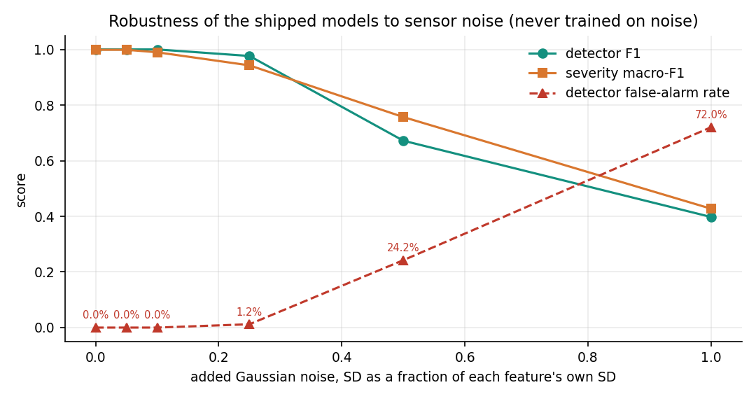
Figure 2: The shipped models are stable up to about 10 percent added noise and degrade sharply beyond 25 percent.

2. FUTURE SCOPE

2.1 Data and models
• Collect real data. Record accelerometer, gyroscope, speed and GPS from phones in ordinary driving, on rough roads, over speed breakers and kerbs, in low-speed bumps and, under a safe protocol (instrumented crash tests, staged low-speed impacts, public crash-reconstruction data), in impacts; retrain and re-measure.
• Make potholes, speed breakers and drops their own classes and add the cases of phone drops, door slams and rough parking.
• Use a window of readings. Replace the single-reading classifier with a model over 1 to 3 seconds of samples (1-D CNN, gradient boosting on window features) and compare it with the forests of this work.
• Train for noise and orientation. Add noise and random phone orientation during training, normalise the axes with the gravity vector, and calibrate the probabilities.
• Consider multi-task learning of the kind in the base paper (one network for detection and severity) and explain predictions with SHAP, once real data make the extra capacity worthwhile.

2.2 Alerting and location
• Send the alert. Add an SMS, voice-call or push gateway, a list of emergency contacts per user and an acknowledgement from the receiver; measure the delivery time.
• Use a real hospital source and road routing. Replace the ten-entry file with a maps or health-registry service giving road distance, traffic, specialty (trauma centre, paediatric) and capacity, and let the recommendation depend on the grade.
• Store alerts with a unique id, user, time and outcome, so that an audit trail and statistics are possible.
• Send location updates after the first alert (the vehicle may be moving or the first fix poor).

2.3 Application quality and security
• Fix the eight validation gaps: reject non-numeric and out-of-range input with 400, bound k, accept only the four severity labels, reject physically impossible readings, and generate unique alert ids.
• Move to a production WSGI server behind HTTPS, store accounts in a database, share the lock-out counter between processes, revoke tokens, and require authentication by default.
• Add automated tests to the repository (pytest, front-end tests), a continuous-integration run, and a pinned requirements file so that the models always load under the version that wrote them.
• Improve accessibility: sound and vibration for the countdown, larger controls, screen-reader announcements already in place to be tested with users.

2.4 Deployment and scale
• A phone client (Android first) that samples the sensors in the background within the operating system's limits, computes the features on the device or streams compressed windows, and keeps the confirmation state machine alive when the app is not in the foreground.
• Edge inference. Export the forests (or a smaller model) to run on the phone so that detection works without coverage and only the alert needs the network.
• Scale the back end with several workers, a queue for alerts and monitoring of latency and error rates.

2.5 Further research
• How early, within a crash, can severity be estimated from phone sensors, and how well does it correlate with injury? This needs linkage with medical outcomes, as the base paper itself notes for its own data.
• What confirmation window and what interface minimise both missed alerts and nuisance alerts under real stress? This needs a user study and, for a regulated service, agreement with emergency authorities.
• Can the false-alarm behaviour on road-surface events be learned from crowd-sourced, privacy-preserving phone data?
• Can a post-event severity model such as the base paper's be fed with the facts available at the scene (vehicle type, road class from the map, time of day) to refine the first grade measured from motion alone?

3. REFERENCES
[1] Y. Wang, Z. Liang and Y. He, "Multi-Task FT-Transformer: A high-performance and interpretable framework for traffic accident severity prediction," IEEE Access, vol. 14, pp. 21585-21606, 2026, doi: 10.1109/ACCESS.2026.3658687.
[2] "Machine learning-based prediction of road accident severity," Int. J. Res. Publication and Reviews, 2025. [Listed in the batch literature survey; authors, volume and pages could not be verified.]
[3] "Advancing road safety: Road accident severity prediction using deep learning models," in Proc. IEEE 27th Int. Conf. Intelligent Transportation Systems (ITSC), 2024. [Listed in the batch literature survey; authors and pages could not be verified.]
[4] "Avoiding road accidents by improving accident severity prediction rates," in Proc. IEEE 21st India Council Int. Conf. (INDICON), 2024. [Listed in the batch literature survey; authors and pages could not be verified.]
[5] "A comprehensive review of machine learning and explainable AI approaches for road accident severity prediction," Iconic Research and Engineering Journals, 2026. [Listed in the batch literature survey; authors, volume and pages could not be verified.]
[6] J. Rocha, S. Soares, A. Valente and F. C. Pinto, "GreenBox: Prototyping of an automatic road accident detection system with real-time notification SMS," arXiv:2606.16468 [eess.SY], Jun. 2026.
[7] S. Ayesha, A. Aslam, M. H. Zaheer and M. B. Khan, "CIRS: A multi-agent machine learning framework for real-time accident detection and emergency response," Sensors, vol. 25, no. 18, Art. no. 5845, Sep. 2025, doi: 10.3390/s25185845.
[8] C. Dashora, P. E. Sudhagar and J. Marietta, "IoT based framework for the detection of vehicle accident," Cluster Comput., vol. 23, no. 2, pp. 1235-1250, 2020.
[9] M. Karthik, L. Sreevidya, K. Vinodha, M. Thangaraj, G. Hemalatha and T. Viswak Sena, "Automatic messaging system by detecting the road accidents for vehicle applications," Mater. Today: Proc., vol. 80, pp. 3124-3128, 2023.
[10] M. Anil Kumar, M. Venkata Suman, Y. Misra and M. Geetha Pratyusha, "Intelligent vehicle black box using IoT," Int. J. Eng. Technol., vol. 7, no. 2.7, pp. 215-218, Mar. 2018.
[11] S. Uma and R. Eswari, "Accident prevention and safety assistance using IoT and machine learning," J. Reliable Intell. Environ., vol. 8, no. 2, pp. 79-103, Jun. 2022.
[12] S. Sharma and S. Sebastian, "IoT based car accident detection and notification algorithm for general road accidents," Int. J. Elect. Comput. Eng. (IJECE), vol. 9, no. 5, pp. 4020-4026, 2019.
[13] N. Hamdan and T. Sipos, "Advancements in machine learning for traffic accident severity prediction: A comprehensive review," Period. Polytech. Transp. Eng., vol. 53, no. 3, pp. 347-355, 2025, doi: 10.3311/PPtr.40369.
[14] Y. Pei, Y. Wen and S. Pan, "Road traffic accident risk prediction and key factor identification framework based on explainable deep learning," IEEE Access, vol. 12, pp. 120597-120611, 2024, doi: 10.1109/ACCESS.2024.3451522.
[15] C. Lin, D. Wu, H. Liu, X. Xia and N. Bhattarai, "Factor identification and prediction for teen driver crash severity using machine learning: A case study," Appl. Sci., vol. 10, no. 5, p. 1675, Mar. 2020.
[16] M.-M. Chen and M.-C. Chen, "Modeling road accident severity with comparisons of logistic regression, decision tree and random forest," Information, vol. 11, no. 5, p. 270, May 2020.
[17] M. Sameen and B. Pradhan, "Severity prediction of traffic accidents with recurrent neural networks," Appl. Sci., vol. 7, no. 6, p. 476, Jun. 2017.
[18] M. Zheng, T. Li, R. Zhu, J. Chen, Z. Ma, M. Tang, Z. Cui and Z. Wang, "Traffic accident's severity prediction: A deep-learning approach-based CNN network," IEEE Access, vol. 7, pp. 39897-39910, 2019.
[19] Y. Gorishniy, I. Rubachev, V. Khrulkov and A. Babenko, "Revisiting deep learning models for tabular data," in Proc. Adv. Neural Inf. Process. Syst., vol. 34, Dec. 2021, pp. 18932-18943.
[20] A. Kendall, Y. Gal and R. Cipolla, "Multi-task learning using uncertainty to weigh losses for scene geometry and semantics," in Proc. IEEE/CVF Conf. Comput. Vis. Pattern Recognit. (CVPR), Jun. 2018, pp. 7482-7491.
[21] L. Breiman, "Random forests," Mach. Learn., vol. 45, no. 1, pp. 5-32, Oct. 2001.
[22] F. Pedregosa et al., "Scikit-learn: Machine learning in Python," J. Mach. Learn. Res., vol. 12, pp. 2825-2830, 2011.
[23] N. V. Chawla, K. W. Bowyer, L. O. Hall and W. P. Kegelmeyer, "SMOTE: Synthetic minority over-sampling technique," J. Artif. Intell. Res., vol. 16, pp. 321-357, 2002.
[24] S. M. Lundberg and S.-I. Lee, "A unified approach to interpreting model predictions," in Proc. Adv. Neural Inf. Process. Syst., vol. 30, 2017, pp. 4765-4774.
[25] R. W. Sinnott, "Virtues of the haversine," Sky and Telescope, vol. 68, no. 2, p. 159, 1984.
[26] World Health Organization, Global Status Report on Road Safety 2023. Geneva, Switzerland: WHO, Dec. 2023.
[27] C. Percival and S. Josefsson, "The scrypt password-based key derivation function," IETF RFC 7914, Aug. 2016.
[28] Meta Platforms, Inc., "React: A JavaScript library for building user interfaces," software, 2013-2026. [Online]. Available: https://react.dev

